**LAB 26**

**STATIC ROUTING**

1. Download the “Lab 26 – Routing.pka” from Leho and open it. It contains this topology:

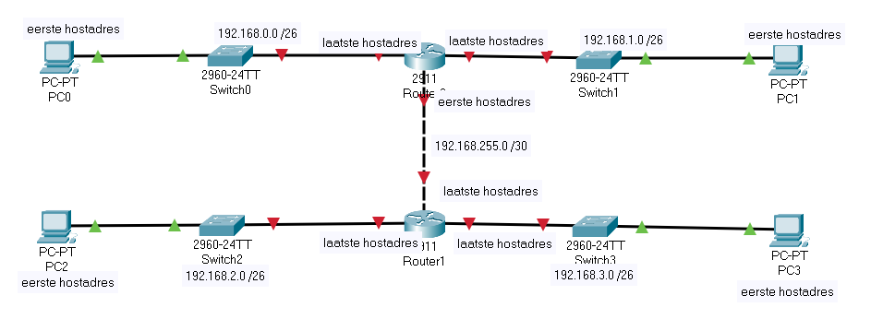

1. How many networks are connected in this topology?

5

1. Calculate the IP host addresses for all hosts and for all interfaces of both routers. (Here, we will not assign IP addresses to the switches for remote management.)

By now, you should be able to calculate that manually. However, you can also use (or verify) with the ‘ipcalc’ tool on linux.

Hint: you can also ‘apt install’ that on WSL in Windows.

|  |  |  |
| --- | --- | --- |
| host | IPv4 IP host address | Default gateway |
| PC0 | 192.168.0.1 | 192.168.0.62 |
| PC1 | 192.168.1.1 | 192.168.1.62 |
| PC2 | 192.168.2.1 | 192.168.2.62 |
| PC3 | 192.168.3.1 | 192.168.3.62 |

|  |  |
| --- | --- |
| router | IPv4 IP host address |
| Router0 left interface | 192.168.0.62 |
| Router0 right interface | 192.168.0.62 |
| Router0 bottom interface | 192.168.255.1 |
| Router1 left interface | 192.168.2.62 |
| Router1 right interface | 192.168.3.62 |
| Router1 top interface | 192.168.255.2 |

How do you write the /26 prefix as dotted decimal subnet mask?

11111111.11111111.11111111.11 000000

How do you write the /30 prefix as dotted decimal subnet mask?

11111111.11111111.11111111.111111 00

1. Apply this IP address configuration to all the hosts (PCs). Thus set the IP address, subnet mask and gateway (we don’t use a DNS server here).
2. Apply this IP address configuration to all interfaces of both routers. Thus set the IP address, subnet mask and gateway (we don’t use a DNS server here).

Hint: if your forgot how to do so, have a look at the lecture/lab about ‘Basic configuration of a Cisco router’.

1. Have a look at the routing table of Router0. Which are the directly connected networks of Router0?

* 192.168.0.0/26
* 192.168.1.0/26
* 192.168.255.0/30

1. Ping from PC0 to PC1. You should find this works because both are in directly connected networks of Router0.
2. Ping from PC0 to PC2. You‘ll find this isn’t working. PC2 is in a remote network for Router0 which the router is currently unaware of.

To make that connectivity work, you’ll have to manually tell Router0 how (via what neighboring router) to reach the network where PC2 resides in = adding a static route to the routing table of Router0. Do this. (Have a look at the lecture slides on how to do so.)

Of course, PC2’s ping replies also need to be able to reach PC0. At Router1, we have the same problem: PC0 is in a remote network for Router1, thus on Router1 we need to add a static route to the network of PC0 so Router1 knows where to forward this packets to.

Verify you’ve added these remote network destinations correctly on both routers by inspecting their routing table. Make sure you manage to ping from PC0 to PC2.

1. Similarly, make sure that you can ping from each PC to any other PC.

Hint: You'll need 2 more commands for execute!

1. The static routes you’ve defined on Router0 to reach the remote networks are all accessible via the same next hop (the IP address of Router1’s top interface). And the same is true for Router1 (all remote networks are accessible via Router0’s bottom interface). This means you could also have used one **default route** on each router instead of different routes for each remote network.

Therefore, let’s replace the static routes with one default route on **Router1** :

* 1. First, delete the 2 previously added static routes.

Hint: preceding a command with keyword ‘**no**’ is how IOS undoes a configuration. (Remember e.g. the ‘no shutdown’ command.)

* 1. What is the IPv4 destination network address and subnet mask for a default route? (See lecture slides.)
  2. Now add a static default route to configure a default route (via the next hop as used before)
  3. Verify the routing table and verify if you all PCs can still ping each other.

You could do the very same thing on Router0, but you can leave the static routes untouched there, that saves you some work today. (And that way we’ll also check if you were able to do it once without and once with default route.)

1. Save the router configuration to the startup-config (in the NVRAM memory) on both routers.
2. Save your PKA file and upload it via Leho.